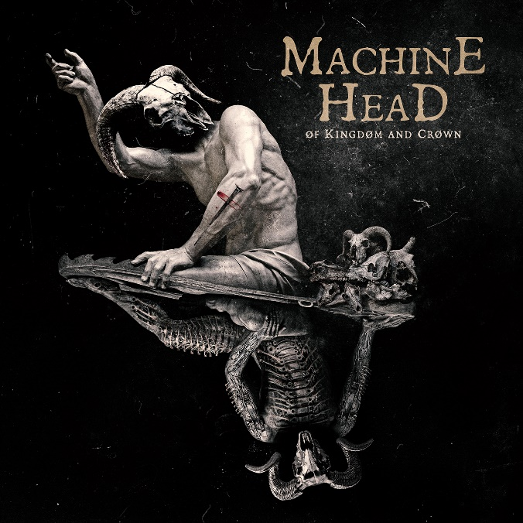

MACHINE HEAD

» ØF KINGDØM AND CRØWN «

OUT: August 26th 2022
Line up: | MACHINE HEAD online:
Robb Flynn | Vocals, Guitar  Waclaw “Vogg” Kieltyka | Guitar  Jared MacEachern | Bass  Matt Alston | Drums | https://www.machinehead1.com/  https://www.instagram.com/machine_head/  https://twitter.com/MfnH  https://www.facebook.com/MachineHead
Undisputed masters of murderous riffs, pugnacious grooves and ferocious hooks since 1991, MACHINE HEAD are long established as one of the most influential and incendiary bands in the metal world.
From genre-expanding triumphs like 1994’s debut, Burn My Eyes, 1999’s The Burning Red to the planet-conquering might of 2007’s The Blackening, to the new life injected in 2014’s Bloodstone and Diamonds, MACHINE HEAD have carved a singular path across the globe for over three decades now with no end in sight. Whether it be marathon 3 hour live performances, or millions of albums sold worldwide, and accolades both big and small, there aren’t too many “distractions” clouding up the vision of Guitarist/Vocalist/Founder Robb Flynn these days.
In 2022, MACHINE HEAD are back with their most crushing and complete album yet. ØF KINGDØM AND CRØWN is an hour-long conceptual monolith, rich in colour and dynamics but hell-bent on destruction. Set in a futuristic wasteland where the sky is always crimson red, ØF KINGDØM AND CRØWN tells the tale of two characters, both faced with incalculable trauma, whose stories become bloodily entwined as this deep, dark record progresses.
“The album and concept was loosely inspired by the Japanese anime series Attack On Titan,” says Robb, “in the sense that in that series, there is no “good” or “bad” guy… both sides believe they’re doing the right thing, but both are committing atrocities and evil.”

Album opener, “SLAUGHTER THE MARTYR,” sets the tone for not only the record, but the aural and psychological exploration the listener is about to embark on. From the first dissonant note, its certain this is not only fresh canvas spelled out with lead vocalist Robb Flynn and bassist Jared MacEachern's soaring vocal harmonies, but its intent is as furious as anything the band has ever come up with. This track also begins the journey of our protagonists.
Further exploration of the damaged psyche blasts forth on “CHØKE ØN THE ASHES ØF YØUR HATE,” a searing back and forth dose of Thrash Metal that could only come from the roots of the Bay Area. Unrelenting in its attack, the breakneck pace only solidifies this as one of many standouts on ØF KINGDØM AND CRØWN.
From the adrenaline rush of exorcising their inner demons to the innate feeling of solitude and regret comes “UNHALLØWED.” A dramatic introspective of questioning one’s motives and the fallout when the debts our expended emotions come to collect. Hopeless, lost, and isolated, protagonist #2 begins the transformation from victim to victimizer over the melodic chaos courtesy of guitarist Vogg Kiełtyka. Radicalized, paranoid, and armed with a dead-end stare, the mental onslaught ignites with the song, “KILL THY ENEMIES.” The whiplash inducing thoughts pair up nicely with some of the thickest grooves on the album.
The album ends with arguably the finest song MACHINE HEAD have ever written: “ARRØWS IN WØRDS FRØM THE SKY”, the grandiose but emotionally visceral climax to the finest and most ferocious album of the band’s 30 year career.
A perennially vital force in heavy music, MACHINE HEAD have continued their exhilarating evolution, while never losing the furious spirit of their old school, underground roots.

